Motivation

The term motivation is derived from the Latin word *movere*, meaning "to move". Motivation can be broadly defined as the forces acting on or within a person that cause the arousal, direction, and persistence of goal-directed, voluntary effort. Motivation theory is thus concerned with the processes that explain why and how human behavior is activated.

Several theorists, including Abraham Maslow, Frederick Herzberg, Douglas McGregor have provided theories to help explain needs as a source of motivation.

**Abraham Maslow’s Need Hierarchy Theory of motivation**

Maslow defined need as a physiological or psychological deficiency that a person feels the compulsion to satisfy. This need can create tensions that can influence a person's work attitudes and behaviors. Maslow formed a theory based on his definition of need that proposes that humans are motivated by multiple needs and that these needs exist in a hierarchical order. His premise is that only an unsatisfied need can influence behavior; a satisfied need is not a motivator.

Maslow's theory is based on the following two principles:

1. **Deficit principle**: A satisfied need no longer motivates behavior because people act to satisfy deprived needs.
2. **Progression principle**: The five needs he identified exist in a hierarchy, which means that a need at any level only comes into play after a lower‐level need has been satisfied.

In his theory, Maslow identified five levels of human needs.

1. **Biological and Physiological needs** - air, food, drink, shelter, warmth, sex, sleep, etc.
2. **Safety needs** - protection from elements, security, order, law, limits, stability, etc.
3. **Belongingness and Love needs** - work group, family, affection, relationships, etc.
4. **Esteem needs** - self-esteem, achievement, mastery, independence, status, dominance, prestige, managerial responsibility, etc.
5. **Self-Actualization needs** - realizing personal potential, self-fulfillment, seeking personal growth and peak experiences.

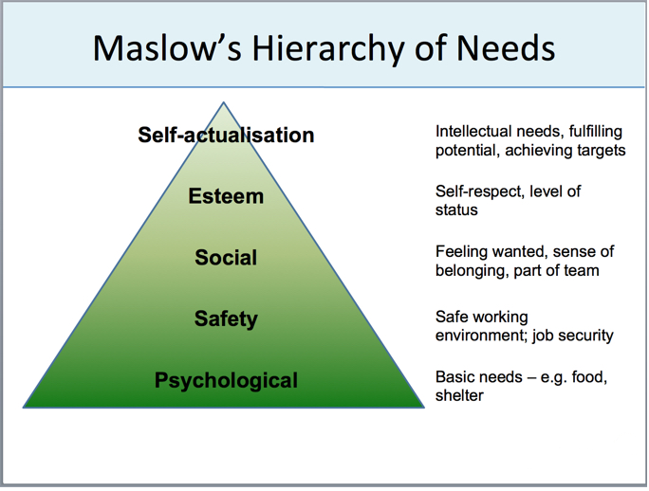

Although research has not verified the strict deficit and progression principles of Maslow's theory, his ideas can help managers understand and satisfy the needs of employees.

**Herzberg's Two-factor Theory of motivation**

Frederick Herzberg offers another framework for understanding the motivational implications of work environments.

In his two‐factor theory, Herzberg identifies two sets of factors that impact motivation in the workplace:

**Hygiene factors** include salary, job security, working conditions, organizational policies, and technical quality of supervision. Although these factors do not motivate employees, they can cause dissatisfaction if they are missing. Something as simple as adding music to the office place or implementing a no‐smoking policy can make people less dissatisfied with these aspects of their work. However, these improvements in hygiene factors do not necessarily increase satisfaction.

**Satisfiers or motivators** include such things as responsibility, achievement, growth opportunities, and feelings of recognition, and are the key to job satisfaction and motivation. For example, managers can find out what people really do in their jobs and make improvements, thus increasing job satisfaction and performance.

Following Herzberg's two‐factor theory, managers need to ensure that hygiene factors are adequate and then build satisfiers into jobs.

**Comparison between Maslow and Herzberg’s Theory of motivation**

**1. Meaning:** Maslow's theory is based on the concept of human needs and their satisfaction. Herzberg's theory is based on the use of motivators which include achievement, recognition and opportunity for growth.

**2. Basis of Theory :** Maslow's theory is based on the hierarchy of human needs. He identified five sets of human needs (on priority basis) and their satisfaction in motivating employees. Herzberg refers to hygiene factors and motivating factors in his theory. Hygiene factors are dissatisfiers while motivating factors motivate subordinates. Hierarchical arrangement of needs is not given.

**3. Nature of Theory:** Maslow's theory is rather simple and descriptive. The theory is based long experience about human needs. Herzberg's theory is more prescriptive. It suggests the motivating factors which can be used effectively. This theory is based on actual information collected by Hertzberg by interviewing 200 engineers and accountants.

**4. Applicability of Theory:** Maslow's theory is most popular and widely cited theory of motivation and has wide applicability. It is mostly applicable to poor and developing countries where money is still a big motivating factor. Herzberg's theory is an extension of Maslow's theory of motivation. Its applicability is narrow. It is applicable to rich and developed countries where money is less important motivating factor.

**5. Descriptive or Prescriptive:** Maslow's theory is descriptive in nature. Herzberg's model is prescriptive in nature.

**6. Motivators:** According to Maslow's model, any need can act as motivator provided it is not satisfied or relatively less satisfied. In the dual factor model of Hertzberg, hygiene factors (lower level needs) do not act as motivators. Only the higher order needs (achievement, recognition, challenging work) act as motivators.

**McGregor’s Theory of Motivation (Theory X and Theory Y)**

Social psychologist Douglas McGregor of MIT expounded two contrasting theories on human motivation and management in the 1960s: The Theory X and the Theory Y. McGregor promoted Theory Y as the basis of good management practice, pioneering the argument that workers are not merely cogs in the company machinery, as Theory X-Type organizations seemed to believe.

**Theory X**

Theory X assumes that employees are naturally unmotivated and dislike working, and this encourages an authoritarian style of management. According to this view, management must actively intervene to get things done. This style of management assumes that workers:

* Dislike working.
* Avoid responsibility and need to be directed.
* Have to be controlled, forced, and threatened to deliver what's needed.
* Need to be supervised at every step, with controls put in place.
* Need to be enticed to produce results; otherwise they have no ambition or incentive to work.

X-Type organizations tend to be top heavy, with managers and supervisors required at every step to control workers. There is little delegation of authority and control remains firmly centralized. McGregor recognized that X-Type workers are in fact usually the minority, and yet in mass organizations, such as large scale production environment, X Theory management may be required and can be unavoidable.

**Theory Y**

This expounds a participative style of management that is de-centralized. It assumes that employees are happy to work, are self-motivated and creative, and enjoy working with greater responsibility. It assumes that workers:

* Take responsibility and are motivated to fulfill the goals they are given.
* Seek and accept responsibility and do not need much direction.
* Consider work as a natural part of life and solve work problems imaginatively.

Management style is strongly influenced by management’s beliefs and assumptions about what motivates members of their team: If it believes that team members dislike work, it will tend towards an authoritarian style of management; On the other hand, if it assumes that employees take pride in doing a good job, it will tend to adopt a more participative style.

**Comparing Theory X and Theory Y**

1. **Motivation:** Theory X assumes that people dislike work; they want to avoid it and do not want to take responsibility. Theory Y assumes that people are self-motivated, and thrive on responsibility.
2. **Management Style and Control:** In a Theory X organization, management is authoritarian, and centralized control is retained, whilst in Theory Y, the management style is participative: Management involves employees in decision making, but retains power to implement decisions.
3. **Work Organization:** Theory X employees tend to have specialized and often repetitive work. In Theory Y, the work tends to be organized around wider areas of skill or knowledge; Employees are also encouraged to develop expertise and make suggestions and improvements.
4. **Rewards and Appraisals:** Theory X organizations work on a ‘carrot and stick’ basis, and performance appraisal is part of the overall mechanisms of control and remuneration. In Theory Y organizations, appraisal is also regular and important, but is usually a separate mechanism from organizational controls. Theory Y organizations also give employees frequent opportunities for promotion.
5. **Application:** Although the Theory X management style is widely accepted as inferior to others, it has its place in large-scale production operation and unskilled production line work. Many of the principles of Theory Y are widely adopted by types of organization that value and encourage participation. Theory Y-style management is suited to knowledge work and professional services. Professional service organizations naturally evolve Theory Y-type practices by the nature of their work; Even highly structured knowledge work, such as call center operations, can benefit from its principles to encourage knowledge sharing and continuous improvement.